Conestoga College
School of Applied Computer Science & Information Technology

PROG8630 – Dashboard Project Proposal

Retail / ShopFlick

Anjali Sharma
Khushboo Joshi
Shivam Kumraa
Saravanan Nadanasabesan

Course Instructor:
Pramod Vasista

March 29, 2025

Abstract

Sales, Marketing, Inventory & Supply Chain, and Customer Service are the four main business divisions that this dashboard is intended to monitor using key performance indicators (KPIs). It increases operational efficiency, optimizes strategic planning, and raises customer happiness by centralizing data from many sources. Decision-makers may more successfully spot patterns, track performance, and make well-informed business decisions with interactive and real-time data visualizations. Simplifying intricate business KPIs and turning them into useful information that keeps companies responsive and competitive is the aim.

In addition to real-time monitoring, the dashboard offers thorough data analysis and tactical suggestions to guarantee efficiency and long-term progress. It enables companies to make data-driven changes by highlighting strengths and important areas for improvement. Stakeholders can easily explore and extract useful information because to the user-friendly interface and intuitive design. In the end, this dashboard acts as a single location for decision-making, allowing businesses to increase efficiency, simplify processes, and achieve long-term success in a market that is changing quickly.

Table of contents

Contents
Introduction 4
Departments 4
Sales Department 5
Marketing Department 5
Inventory and Supply Chain Department 6
Customer Service Department 6
Dashboard Mockup 7
Data Source and Data Model 11
Tool Selection 18
Update/Refresh Plan 19
Testing Strategy 19
Dashboard Visuals…………………………………………………………………………. 22
Guidelines/Instructions and Users Guide ……………………………………………. 24
Proposed Allocation Project Team Roles 31
Project Timeline 31
Bibliography 32

Introduction
The Shop Flick dashboard is a clever business solution made to assist organizations in tracking and enhancing important procedures. In four primary areas—sales, marketing, inventory & supply chain, and customer service—it compiles data from many sources and displays it in understandable, interactive visualizations.
Businesses can analyze performance, monitor trends, and make data-driven choices all in one location with this dashboard. Enhancing customer happiness, cutting expenses, and increasing overall efficiency are the primary objectives. By offering dynamic visuals and real-time information, it assists companies in creating more effective long-term growth and success plans.

Departments
The data from the following four departments of the company will be represented on the dashboard: Sales, Marketing, Inventory & Supply Chain, and Customer Service. Each one of them is vital with respect to consumer delight, operational excellence, and, eventually corporate success.

A well-structured dashboard would enable the departments to keep track of the Key Performance Indicators, therefore, make informed decisions by analyzing the data to gain insights about the steps that can be followed or need to be initiated. With visualization, this dashboard will graphically show appropriate KPIs for various strengths, weaknesses, and areas of improvement in each department.

In the sections that follow, each of these will be discussed in detail, including what business-critical questions they each need to be able to answer, and what are the KPIs by which success will ultimately be measured.

Department 1
2.1 The Department of Sales
Objective: Monitor revenue patterns, track sales performance, and offer insights into regional and product sales.
Important Queries:
• Which goods and geographical areas bring in the most revenue?
• What has been the revenue pattern over time?
KPIs:
1) Total revenue: The sum of all sales revenue for a specific time period.
2) Sales Growth Rate (%) - (Revenue from Current Period - Revenue from Previous Period) / Past Period Revenue) * 100.
3) Top 5 Products by Revenue: This is a ranking of the top-selling items.
4) Regional Sales Distribution: This is the breakdown of sales income percentages by region.

Department 2
2.2 The Department of Marketing
Objective: Optimize campaign tactics and assess the efficacy of marketing.
Important queries:
• How much does a marketing campaign's return on investment (ROI) look like?
• Which marketing platforms provide the most leads or revenue?
KPIs.
1) Customer Acquisition Cost (CAC): The sum of marketing costs divided by the number of new clients attracted.
2) Return on Investment (ROI): each campaign is calculated as follows: (Cost of Campaign - Campaign Revenue) / Campaign Cost.
3) Channel-specific Conversion Rate (%) - (Number of Conversions / Total Visitors) * 100.
4) Social Media Engagement (Clicks, Likes, Shares): The sum of user engagements for each campaign.

Department 3
2.3 Supply Chain & Inventory
Objective: Increase supply chain efficiency and optimize stock levels.
Important queries include:
• Are inventory levels set up to satisfy demand?
• How well do orders get filled?
KPIs:
1) Inventory Turnover Ratio: COGS (cost of goods sold) / average inventory value.
2) Stock-out Rate (%) = (Number of Stock-outs / Total SKU Inventory) * 100.
3) Average order fulfillment time: It is the amount of time between placing an order and having it delivered.
4) Supplier Reliability Score: The proportion of suppliers' deliveries that arrive on time.

Department 4
2.4 Customer Service
Objective: The goal is to evaluate client satisfaction and enhance response times.
Important queries:
• What are the most common reasons why customers complain?
• To what extent do clients find our service satisfactory?
KPIs
1) Customer Satisfaction Score (CSAT): Positive responses ÷ Total responses * 100.
2) Net Promoter Score (NPS): % Detractors - % Promoters.
3) Average Complaint Resolution Time: Total resolution time ÷ Number of complaints.
4) Client Complaints by Category: Count of complaints categorized by type.

Dashboard Mockup

The ShopFlick Dashboard Mockup aims to provide interactive and real-time data analysis in four business main areas: Sales, Marketing, Inventory & Supply Chain, and Customer Service. It follows that below is a step-by-step breakdown of each area, its most significant metrics, and how they will be presented.

1️.Sales Department Mockup
Goal:
Track product performance, revenue trends, and geographic sales distribution to optimize business strategy.
Key Metrics (KPIs):
- Total Sales Revenue (Revenue earned in a period)
- Top-Selling Products(Which products generate the most revenue?)
- Sales Growth Rate(Month-over-month revenue growth rate)
- Sales by Region(Revenue per geographic area)
- Customer Purchase Trends (What are customers buying the most?)
Visual Components:
- Bar Chart:Sales by Region
- Line Graph: Revenue Trends Over Time
- Pie Chart:Product Category Sales Distribution
- Table:Top 5 Best-Selling Products with Revenue
Filters Applied:
Date Range Filter(e.g., last month, last quarter, last year)
Region Filter(e.g., North America, Europe, Asia)
Product Category Filter (e.g., Electronics, Clothing, Furniture)

2️.Marketing Department Mockup
Objective:
Analyze the effectiveness of marketing campaigns and identify high-performing channels to improve ROI.
Key Metrics (KPIs):
- Return on Investment (ROI)(Profitability of marketing campaigns)
- Customer Acquisition Cost (CAC)(What does it cost to acquire a new customer?)
- Conversion Rate(How many users take a desired action, e.g., buy, sign up?)
- Engagement Rate by Channel (Which channels are driving the most traffic?)
- Social Media Performance (Clicks, likes, shares, and comments on platforms)
Visual Components:
Heatmap: Engagement of Customers through Marketing Channel
Bar Chart:Comparison of ROI in Different Campaigns
Line Graph: Trends in Website Traffic and Conversion of Leads
Funnel Chart:Customer Path from Click to Buying
Filters Applied:
Marketing Channel Filter (such as Google Ads, Facebook Ads, Instagram)
Campaign Filter (such as Holiday Sale, Summer Discount)
Region Filter (Location-based market segmentation)

3️.Mockup of Inventory & Supply Chain

Objective:
Supply adequate stock levels, reduce shortages, and maximize the supply chain to facilitate effective running.
Measures of Main Importance (KPIs):
- Stock Availability Rate (Percent in stock)
- Inventory Turnover Ratio:(How frequently is inventory sold and restocked within an interval?)
- Order Fulfillment Time:(Order fulfillment time taken from order entry to delivery)
- Supplier Performance Score:To what extent are suppliers reliable to deliver stock in time?)
- Backorder Rate (Product out-of-stock percentage when ordered by customers)
Visual Components:
Bar Chart: Top Products' Inventory Levels
Gauge Chart: Order Fulfillment Efficiency (%)
Line Graph: Trends in Stock Availability Over Time
Table: Supplier Performance Ratings
Filters Applied:
Product Category Filter (e.g., Electronics, Clothing, Accessories)
Supplier Filter (Analyze performance per supplier)
Stock Status Filter (e.g., In Stock, Low Stock, Out of Stock)

4️.Customer Service Mockup

Objective:
Measure customer satisfaction, identify frequent complaints, and improve support quality.
Key Metrics (KPIs):
- Customer Satisfaction Score (CSAT): Customer feedback ratings between 1 and 5)
- Net Promoter Score (NPS): Percentage of customers who will recommend the brand to others)
- Average Response Time:How long is it before responding to a customer question?)
- Issue Resolution Rate :Percentage of complaints successfully resolved)*
- Common Complaint Categories :What are the most prevalent customer issues?
Visual Elements:
Pie Chart: Breakdown of Complaint Categories
Bar Chart: Customer Satisfaction Score by Region
Line Graph: Avg Resolution Time Trends by region
Stacked Column Chart: Customer Complaints with Resolution Status
Filters Applied:
Complaint Type Filter (e.g., Late Delivery, Product Quality, Refund Issues)
Customer Feedback Date Range
NPS Score card
Total Complaints card
Region Filte (Analyze customer service performance per location)

How the Mockup Supports Better Decision-Making
The ShopFlick Dashboard is designed to transform complex business data into actionable insights through a structured mockup approach that provides:

Real-time visibility into performance metrics
Data-driven decision-making across departments
Identification of growth opportunities & strategy optimization
Enhanced monitoring of customer satisfaction and issue resolution
Automated reporting & trend analysis

- Sales Dashboard Mockup:
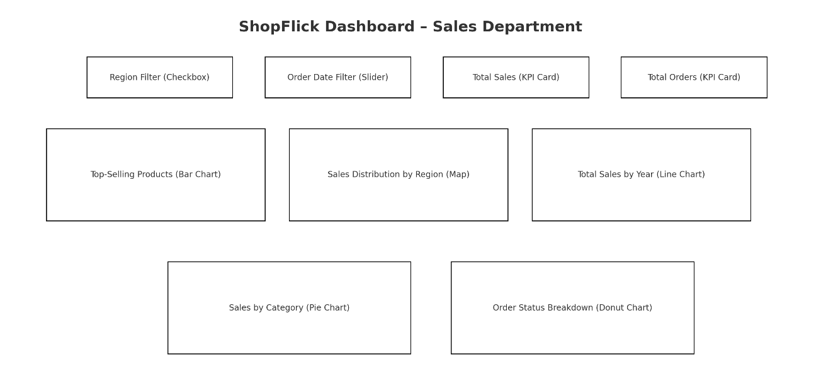
- Marketing Dashboard Mockup:
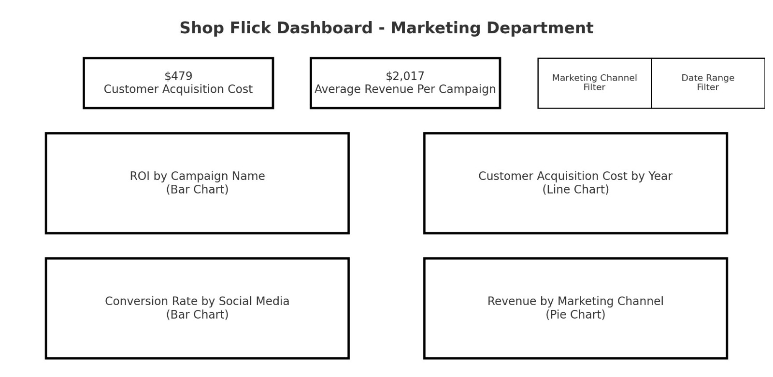

- Supply Chain Dashboard Mockup:

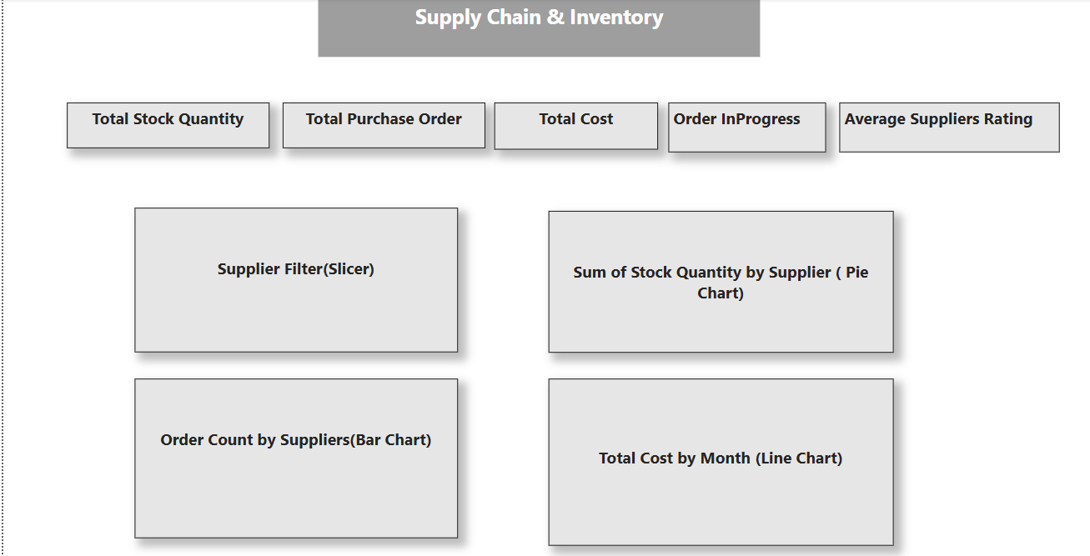

- Customer service Dashboard Mockup:

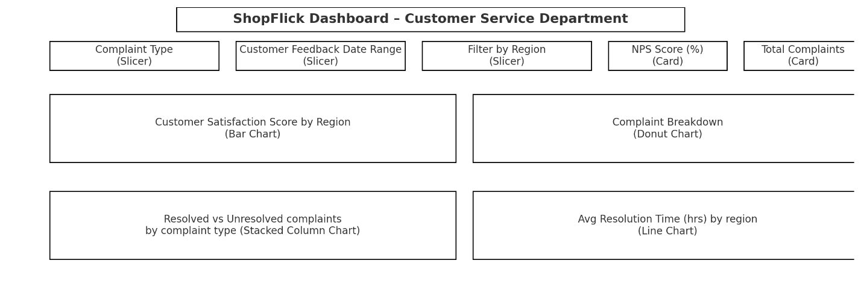

Data Source and Data Model
1) Sales Department

SQL Table Structure:

-- ************** SHARED CORE TABLES **************
CREATE TABLE Customers (
customer_id INT PRIMARY KEY,
first_name VARCHAR(50),
last_name VARCHAR(50),
email VARCHAR(100) UNIQUE,
registered_date DATE
);

CREATE TABLE Products (
product_id INT PRIMARY KEY,
product_name VARCHAR(100) UNIQUE,
category VARCHAR(50),
unit_price DECIMAL(10,2),
discontinued BOOLEAN DEFAULT FALSE
);

-- ************** SALES DEPARTMENT **************
CREATE TABLE Regions (
region_id INT PRIMARY KEY,
region_name VARCHAR(50) UNIQUE,
sales_target DECIMAL(12,2)
);

-- Orders now support multiple products through Order_Items
CREATE TABLE Orders (
order_id INT PRIMARY KEY,
customer_id INT NOT NULL,
region_id INT NULL, -- Fixed: NULL allowed since ON DELETE SET NULL
order_date DATE,
total_amount DECIMAL(12,2),
order_status VARCHAR(20) CHECK (order_status IN ('Pending', 'Shipped', 'Delivered', 'Returned')),
CONSTRAINT fk_orders_customer FOREIGN KEY (customer_id) REFERENCES Customers(customer_id) ON DELETE CASCADE,
CONSTRAINT fk_orders_region FOREIGN KEY (region_id) REFERENCES Regions(region_id) ON DELETE SET NULL
);

CREATE TABLE Order_Items (
order_item_id INT PRIMARY KEY,
order_id INT NOT NULL,
product_id INT NOT NULL,
quantity INT,
unit_price DECIMAL(10,2),
discount DECIMAL(5,2) DEFAULT 0,
CONSTRAINT fk_order_items_order FOREIGN KEY (order_id) REFERENCES Orders(order_id) ON DELETE CASCADE,
CONSTRAINT fk_order_items_product FOREIGN KEY (product_id) REFERENCES Products(product_id) ON DELETE CASCADE
);

ER Diagram

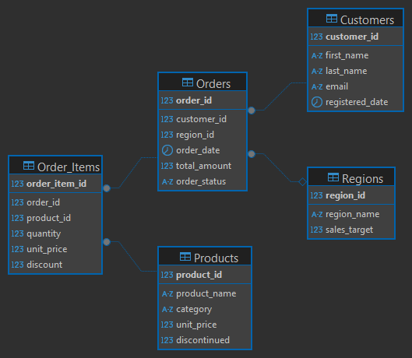

2) Marketing Department

CREATE TABLE Campaigns (
campaign_id INT PRIMARY KEY,
campaign_name VARCHAR(100) UNIQUE,
campaign_type VARCHAR(30),
cost DECIMAL(12,2),
revenue_generated DECIMAL(12,2),
start_date DATE,
end_date DATE
);

CREATE TABLE Lead_Sources (
lead_source_id INT PRIMARY KEY,
source_name VARCHAR(50) UNIQUE
);

CREATE TABLE Leads (
lead_id INT PRIMARY KEY,
campaign_id INT,
lead_source_id INT,
customer_id INT,
status VARCHAR(20) CHECK (status IN ('New', 'Contacted', 'Converted', 'Lost')),
CONSTRAINT fk_leads_campaign FOREIGN KEY (campaign_id) REFERENCES Campaigns(campaign_id) ON DELETE SET NULL,
CONSTRAINT fk_leads_source FOREIGN KEY (lead_source_id) REFERENCES Lead_Sources(lead_source_id) ON DELETE SET NULL,
CONSTRAINT fk_leads_customer FOREIGN KEY (customer_id) REFERENCES Customers(customer_id) ON DELETE CASCADE
);

ER Diagram

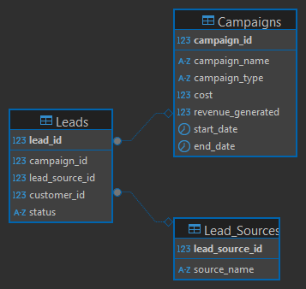
3) Inventory & Supply Chain Department

CREATE TABLE Suppliers (
supplier_id INT PRIMARY KEY,
supplier_name VARCHAR(100) UNIQUE,
reliability_rating DECIMAL(3,2)
);

CREATE TABLE Inventory (
inventory_id INT PRIMARY KEY,
product_id INT NOT NULL,
stock_quantity INT,
reorder_threshold INT,
last_restock_date DATE,
CONSTRAINT fk_inventory_product FOREIGN KEY (product_id) REFERENCES Products(product_id) ON DELETE CASCADE
);

CREATE TABLE Purchase_Orders (
po_id INT PRIMARY KEY,
supplier_id INT NULL, -- Fixed: Allows NULL values when supplier is deleted
order_date DATE,
total_cost DECIMAL(12,2),
delivery_status VARCHAR(20) CHECK (delivery_status IN ('Ordered', 'Shipped', 'Received')),
CONSTRAINT fk_purchase_orders_supplier FOREIGN KEY (supplier_id) REFERENCES Suppliers(supplier_id) ON DELETE SET NULL
);

CREATE TABLE PO_Items (
po_item_id INT PRIMARY KEY,
po_id INT NOT NULL,
product_id INT NOT NULL,
quantity INT,
unit_cost DECIMAL(10,2),
CONSTRAINT fk_po_items_po FOREIGN KEY (po_id) REFERENCES Purchase_Orders(po_id) ON DELETE CASCADE,
CONSTRAINT fk_po_items_product FOREIGN KEY (product_id) REFERENCES Products(product_id) ON DELETE CASCADE
);

ER Diagram

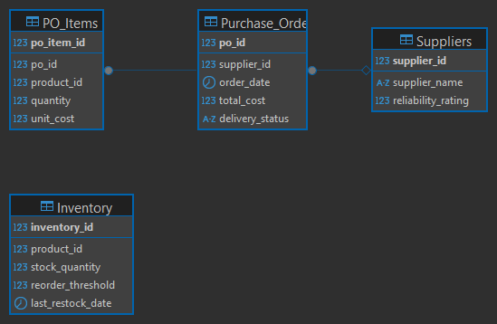

4) Customer Service Department

CREATE TABLE Complaint_Types (
type_id INT PRIMARY KEY,
type_name VARCHAR(50) UNIQUE
);

CREATE TABLE Complaints (
complaint_id INT PRIMARY KEY,
customer_id INT NOT NULL,
order_id INT,
type_id INT,
description TEXT,
resolution_time INT, -- In hours
CONSTRAINT fk_complaints_customer FOREIGN KEY (customer_id) REFERENCES Customers(customer_id) ON DELETE CASCADE,
CONSTRAINT fk_complaints_order FOREIGN KEY (order_id) REFERENCES Orders(order_id) ON DELETE SET NULL,
CONSTRAINT fk_complaints_type FOREIGN KEY (type_id) REFERENCES Complaint_Types(type_id) ON DELETE SET NULL
);

CREATE TABLE NPS_Surveys (
survey_id INT PRIMARY KEY,
customer_id INT,
score INT CHECK (score BETWEEN 0 AND 10),
survey_date DATE,
feedback_category VARCHAR(20),
CONSTRAINT fk_nps_surveys_customer FOREIGN KEY (customer_id) REFERENCES Customers(customer_id) ON DELETE CASCADE
);

CREATE TABLE Customer_Dimension (
customer_id INT PRIMARY KEY,
region VARCHAR(50)
);

ER Diagram

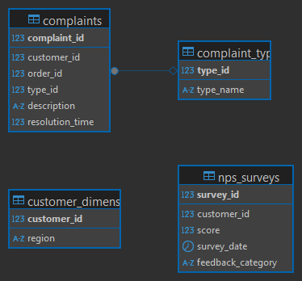

Final ER Diagram
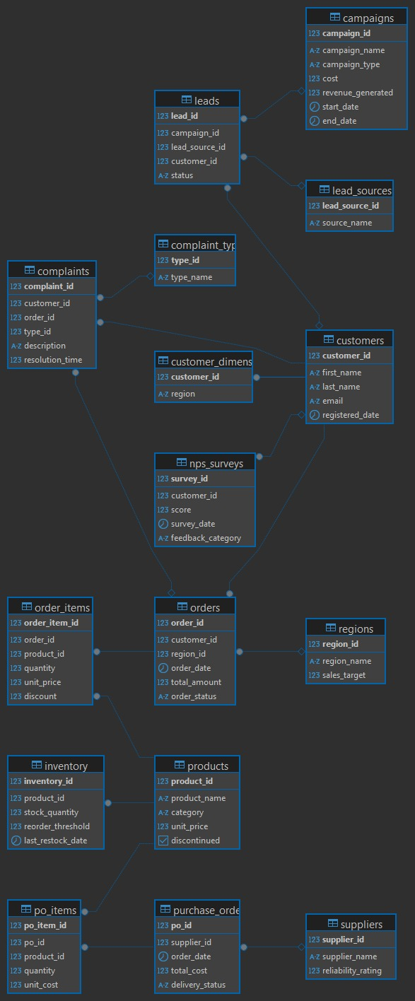

Tool Selection
Our primary tool for creating the dashboard for this project is Microsoft Power BI. The well-known and potent business intelligence application Power BI facilitates the creation of dynamic and interactive data representations. Here's why we chose it:

- Industry Wide Usage: Power BI finds widespread usage in numerous industries, thus it is an excellent tool to master and implement practically.
- Connecting to Multiple Data Sources: It provides seamless data integration by drawing out data from databases, cloud, and spreadsheet sources.
- Excellent for Data Visualization: Power BI is a great tool that has so many interactive reports, charts, and graphs. They are very user friendly and easy to understand
- Automatic Updates: One of the most important feature of power BI is that it gets automatic updates and its really easy to update the dashboards
- Easy to Use: Its drag-and-drop interface makes it simple for even novices to create and edit reports.
- Scalable & Secure: It provides security measures to limit data access and is suitable for companies of any size.

Using Power BI for our ShopFlick Dashboard guarantees that we can make well-informed decisions, analyze data efficiently, and get practical experience with a leading industry technology.

Update/Refresh Plan
Every week, the dashboard will be refreshed to make sure the data is up to date.
The amount of manual labor will be reduced when we employ automated scripts to retrieve the most recent data from linked sources.
The dashboard will be carefully updated whenever new datasets are added to ensure that all the data is correct and current.

Testing Strategy

Functional Testing:

Data Validation: process ensures consistency between raw datasets (e.g., sales transactions, marketing campaign logs) and dashboard reports. For instance, sales revenue figures on the dashboard must be equal to aggregated figures from source systems, and marketing ROI calculations must be equal to CRM records. Edge cases, i.e., missing inventory records or negative customer feedback scores, are tested to make sure the system displays "N/A" or flags discrepancies instead of crashing.

Formula accuracy: prioritizes validation of KPIs that are critical to department decision-making. For example, the Sales Growth Rate formula [(Current Revenue – Past Revenue) / Past Revenue] is validated across time periods (monthly/quarterly) to match financial reports. Similarly, the Inventory Turnover Ratio (COGS / Average Inventory) is cross-checked with supply chain databases to prevent mismatches. Automated scripts simulate scenarios like zero-value marketing costs to validate CAC calculations are always accurate.

Filter and trigger behavior: It is checked to ensure interactive elements work together in tandem. Date range filters on the Sales dashboard should update revenue trends in line charts dynamically, while regional filters should update bar charts and regional sales tables. Triggers like hover over "Top 5 Products" should reveal accurate tooltips, while multi-select filters (like marketing channels) should update heatmaps promptly with no lag.

Non-Functional Testing

User interface: This testing ensures the dashboard is responsive on devices. For example, the Customer Service pie chart (complaint types) must be readable on mobile screens, whereas marketing funnel charts are to avoid label overlap on tablets. Large data sets such as 10,000+ inventory records are tested to load tables and supplier performance gauges within 2–3 seconds without layout distortion.

Compatibility testing: It encompasses browser-specific behavior: Chrome and Safari must render Sales region filters identically, and iOS devices must be touch-friendly for zooming into marketing heatmaps. Fonts and colors utilized in the CSAT score charts are tested for consistency between Windows (Edge) and macOS (Safari) for brand consistency.

Performance testing: the purpose of this testing is to make sure that everything is loading on time and user does have to wait longer for the results. For example If we get more traffic then it should be able to handle. Since this is a dashboard we need to make sure that dashboard is not bloated with unnecessary things and is loading on time.

Dashboard Visuals:

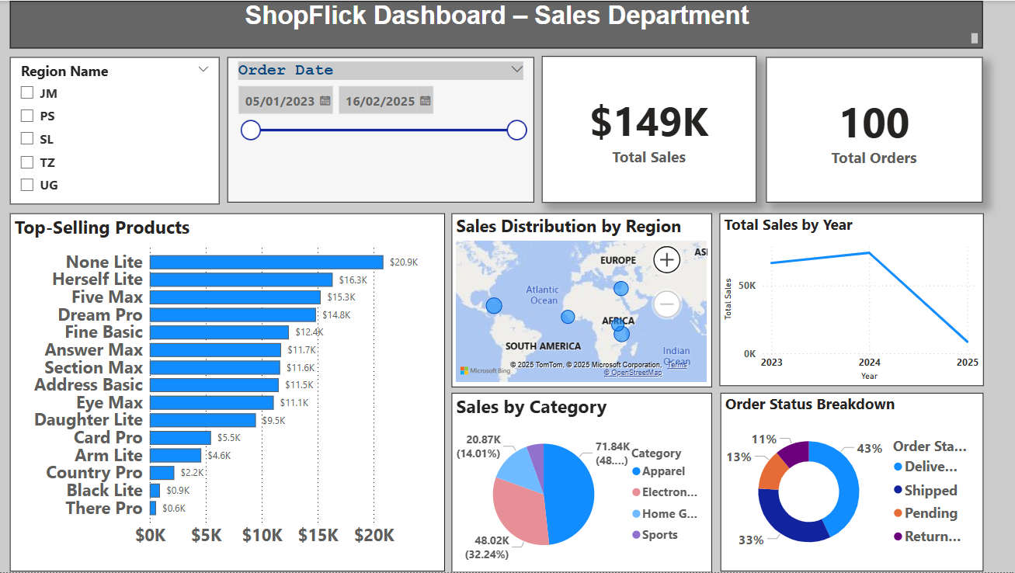

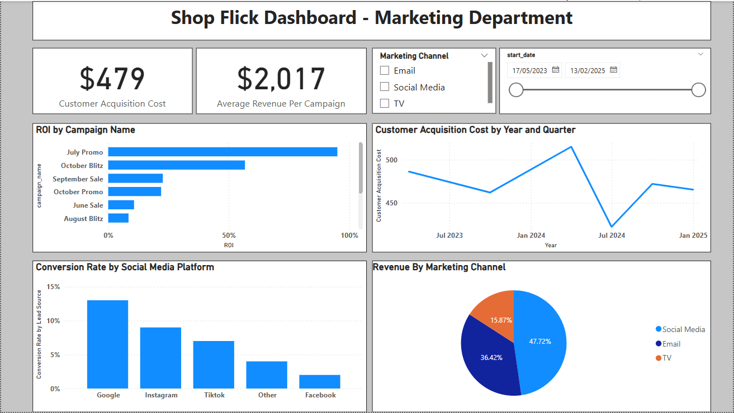
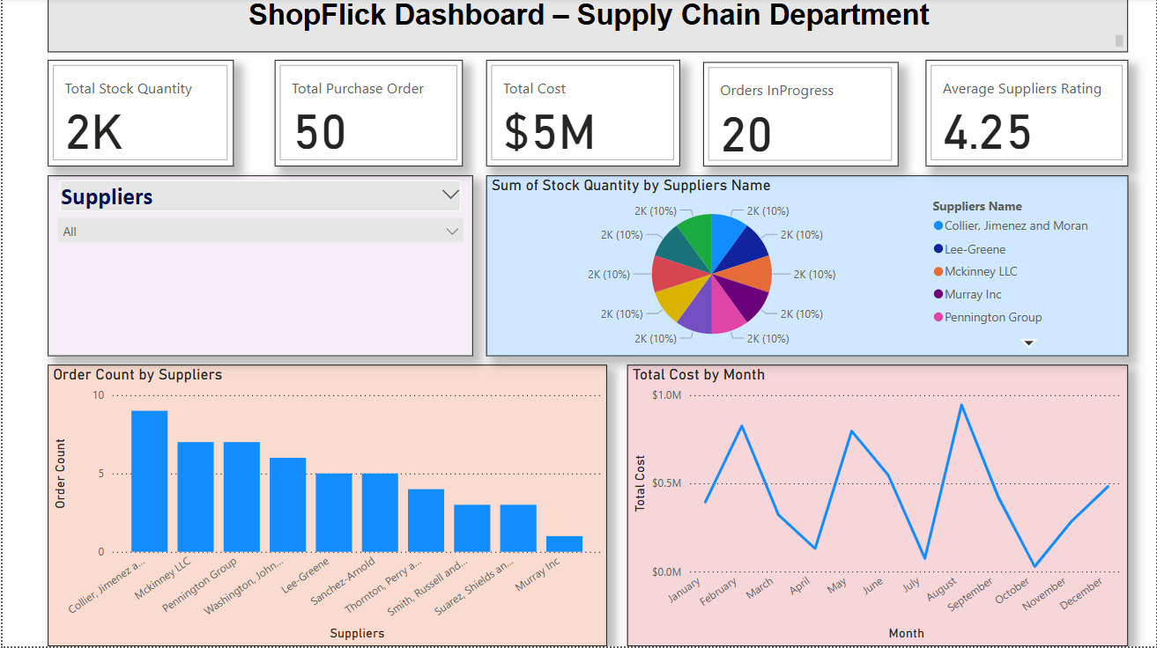

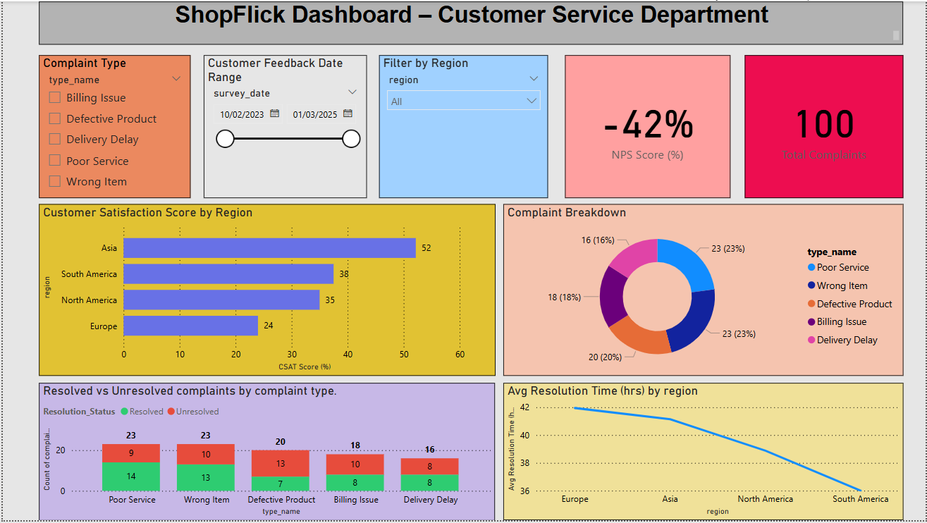

Guidelines/Instructions and Users Guide
Welcome to the ShopFlick Business Intelligence Dashboard, Sales, marketing, supply chain & inventory, and customer service are the four primary business categories that may be explored using the powerful and dynamic Business Intelligence Dashboard.

This guide will show you how to use the dashboard, interact with its features, and confidently interpret the visual insights, whether you're a manager keeping an eye on trends, a team member assessing the success of a campaign, or a student examining KPIs.

The dashboard is user-friendly, robust, and full of useful business data, even if you have never used it before.

Navigating the Dashboard
Each of the dashboard's four main tabs corresponds to a different company department:
- Sales
- Marketing
- Supply Chain & Inventory
- Customer Service

The top or side panel can be used for navigation, depending on your screen or version. Visual components including charts, graphs, KPI cards, and slicers are included in each tab and are all customized to meet the unique requirements of that department.

You can easily explore real-time trends and insights with these visualizations, which automatically refresh when you interact with the filters.

The Effective Use of Filters
One of this dashboard's most potent features is the filter. They help you focus on important patterns and prevent information overload by enabling you to narrow down on material that is pertinent to your investigation.
Throughout the dashboard, the following are the most popular filters:
Date Range: Examine data from particular time periods, such as the latest 30 days, a quarter, or a fiscal year.
Region: Pay attention to geographical performance (e.g., North America, Asia, Europe).
Product Category: Sorts items by categories, such as apparel or electronics, on the Sales and Inventory tabs.
The Marketing tab's Campaign Type/Marketing Channel feature is used to separate campaign efficacy by channel, such as social media, TV, and email.

Type of Customer Complaint: This feature allows you to investigate problems like poor service, delayed deliveries, or defective products under the Customer Service page.

Every filter helps you obtain insight without requiring you to work with spreadsheets or raw data by dynamically updating all related charts and graphics.

An Overview of Each Department and How to Use It
1. Sales Dashboard
Goal: To track sales by region, discover best-selling products, analyze trends over time, and keep an eye on overall sales success.
Key Features:
- Top-Selling Products (Bar Chart):
It Shows the top-selling items according to overall sales. aids in determining popular products and provides information for marketing or inventory choices.
- Total Sales & Total Orders (KPI Cards):
Provides a concise, high-level overview of the quantity of orders and income produced in the chosen period and area.
- Sales Distribution by Region (Map Visual):
Shows the locations of your customers' purchases, emphasizing the global sales concentration.
- Total Sales by Year (Line Graph):
You may see increases, dips, or seasonality over time with the help of this chart, which displays the annual sales performance.
- Sales by Category (Pie Chart):
Dissects overall sales by product category, including sports, electronics, home goods, and apparel.
- Order Status Breakdown (Donut Chart):
To evaluate fulfillment and delivery concerns, it shows the current order status across the following categories: Delivered, Shipped, Pending, and Returned.
How to Use It:
- To concentrate on nations and time periods, use the Region Name and Order Date filters at the top.
- To find out which products are doing the best, look at the Top-Selling Products bar chart.
- The brief overview of overall performance can be obtained by viewing the Total Sales and Total Orders cards.
- To identify where the majority of sales are coming from worldwide, look at the map.
- To monitor changes in sales from year to year, use the Line Chart.
- To compare sales across various product categories, use the pie chart.
- To find out how many orders are shipped, returned, pending, or delivered, view the Donut Chart.

2. Marketing Dashboard
Goal: To monitor client acquisition expenses, assess conversions and income across several channels, and assess the efficacy of marketing initiatives.
Key Features:
- Customer Acquisition Cost & Average Revenue (KPI Cards):
A high-level perspective of marketing effectiveness is provided by KPI Cards, which show the average income per campaign and the cost to acquire a customer.
- ROI by Campaign Name (Bar Chart):
This helps you determine which campaigns yielded the most return on investment.
- Customer Acquisition Cost by Year and Quarter (Line Graph):
Shows trends or peaks that might require more investigation by tracking the evolution of acquisition expenses over time.
- Conversion Rate by Social Media Platform (Bar Chart):
Evaluates the effectiveness of various platforms (such as Google, Instagram, and TikTok) in turning leads into paying consumers.
- Revenue by Marketing Channel (Pie Chart):
Insight into performance distribution is provided by this pie chart, which breaks down revenue contributions from channels such as TV, email, and social media.
- Filters:
  - Marketing Channel filter enables you to concentrate on platforms.
  - Date Range filter analysis can be limited to any time period.

How to Use It:
- Utilize the Date and Marketing Channel filters to concentrate on platforms or campaign times.
- To learn about the cost per customer and total campaign efficiency, look at the KPI cards.
- Examine the ROI bar chart to evaluate the effectiveness of different campaigns.
- To observe the trend of acquisition expenses over time, use the line chart.
- Examine the conversion bar chart to determine the most effective social media channels.
- View the pie chart to determine which marketing channels are bringing in the most money.

3. Supply Chain & Inventory Dashboard
Goal: Is to keep an eye on supplier performance and maintain ideal stock levels.

Key Features:
- Stock, Orders, Cost & Rating (KPI Cards):
Provides a high-level overview of supply chain performance by showing the overall amount of stock, the number of buy orders, the total cost of procurement, the orders that are pending, and the average supplier rating.
- Sum of Stock Quantity by Supplier Name (Pie Chart):
Helps determine stock share and supplier contribution by displaying the distribution of inventory across several providers.
- Order Count by Suppliers (Bar Chart):
Shows the number of orders that each supplier has completed; this is helpful for evaluating the dependability and activity of vendors.
- Total Cost by Month (Line Chart):
Monitors monthly procurement expenses to spot trends in spending, peak seasons, or overspending.
Filters:
- You can concentrate on specific vendors by using the Supplier Filter.
- If used, the Date Range Filter can assist in limiting cost and stock data to particular time frames.

How to Use It:
- To see the performance and stock contributions of particular vendors, use the Supplier filter.
- For a brief overview of stock levels, order activity, and overall expenses, see the KPI cards.
- To discover which suppliers are making the most contributions to inventories, consult the pie chart.
- Examine the bar chart to see how many orders each provider has.
- Track the monthly variations in procurement expenses with the line chart.
- This dashboard assists in making sure you're maintaining ideal inventory levels, working with reputable suppliers, and efficiently controlling expenditures.

4. Customer Service Dashboard
Goals: Track resolution timelines, identify recurring complaints, and evaluate customer satisfaction.
Key Features:
- NPS Score & Total Complaints (KPI Cards):
Provides an immediate performance overview by displaying the total number of complaints received and the Net Promoter Score (NPS), which measures overall customer mood.
- Customer Satisfaction Score by Region (Bar Chart):
Shows satisfaction levels in different parts of the world to show where service quality is good or needs work.
- Complaint Breakdown (Donut Chart):
Shows the proportion of complaints by category, such as Delivery Delay, Wrong Item, or Poor Service, to identify reoccurring problems.
- Resolved vs Unresolved Complaints by Type (Stacked Bar Chart): Sorts complaints by type and compares the number of resolved versus unsolved complaints to track service effectiveness.
- Average Resolution Time by Region (Line Chart):
Assists in identifying delays in customer care response by displaying the typical time required to address complaints in each region.
Filters:
- The Complaint Type Filter aids in limiting the display to particular complaint types.
- Users can access data across a chosen customer feedback period by using the Date Range Filter.
- The Region Filter modifies images to highlight particular geographic areas.

How to Use It:
- To narrow down your analysis, use the Complaint Type, Date, and Region filters.
- To find out how many complaints were filed and the general customer attitude (NPS), look at the KPI cards.
- To determine which regions have high or low satisfaction scores, look at the bar chart.
- To learn about the most typical complaint types, consult the donut chart.
- To monitor how effectively your team is handling each kind of complaint, use the stacked bar chart.
- To see which areas have quicker or slower complaint resolution times, look at the line chart.

Data Refresh & Updates:
Automated scripts that retrieve data from underlying SQL databases are used to update the dashboard once a week. Unless new data sources are added, all changes are automatically reflected, negating the need for manual intervention.
The team's data analyst oversees organizing updates and refresh schedules.

Tips for First-Time Users:
- To view tooltips and detailed values, hover over any chart.
- To drill down into a particular bar or pie segment, click on it.
- "Reset Filters" should be used if the images appear erratic or blank.
- To avoid blank results, don't apply too many filters at once.

Compatibility Notes:
- For the best experience, view on a desktop computer or laptop.
- There is compatibility for mobile and tablet versions, although the visual spacing may differ.
- Microsoft Edge or Google Chrome are the best options.

Do You Need Assistance?
If you run into problems or have inquiries concerning the figures, computations, or data:
- Sarvanan Nadanasabesan is the dashboard developer (Power BI logic and visuals).
- Shivam Kumraa, a data analyst (data queries, SQL, and computations)

They can help with questions about data or technical problems.

The following guide will help users explore valuable insights, engage with the ShopFlick dashboard with confidence, and support better business decisions. Regardless of your role—stakeholder, peer reviewer, or end-user—the dashboard is designed to be clear, precise, and informative.

Proposed Allocation Project Team Roles
Role | Name | Responsibilities | Department
Project Manager | Anjali Sharma | Oversees project execution ensures timely completion. | Sales
Data Analyst | Shivam Kumraa | Gathers, cleans, and structures data for visualization. | Marketing
Dashboard Developer | Sarvanan Nadanasabesan | Develops the dashboard using Power BI. | Customer Service
Report Writer | Khushboo Joshi | Documents insights, analysis, and business recommendations. | Supply Chain & Inventory

Meeting Frequency: Weekly team meetings will be conducted via online collaboration tools to ensure consistent progress.

Project Timeline

Date | Deliverable | Responsible
FEB 25 | Data Collected and planned | Shivam Kumraa
MAR 5 | 1st Draft of Dashboard Circulated to Team | Khushboo Joshi
MAR 10 | 1st Draft of Presentation Circulated | Team
MAR 15 | Errors and improvements were found through team user testing. | All Members
MAR 20 | Final Adjustments made and checked | Anjali Sharma
MAR 29 | Dashboard and Report Due at 11.59pm | Sarvanan Nadanasabesan
APR 04 | Project Presentation | All Members
APR 07 | End User Commentary | All Members
APR 10 | Revisions | All Members

Bibliography

- Ferrari, A., & Russo, M. (2016). Introducing Microsoft Power BI. Microsoft Press.
- Kumar, S. M., & Belwal, M. (2017, August). Performance dashboard: Cutting-edge business intelligence and data visualization. In 2017 (pp. 1201-1207). IEEE.
- Planning a Data Visualization Project -https://guides.lib.udel.edu/dataviz/home
- College C. (n.d). Week 6 PROG8630-L06b-23F1 [PowerPoint slides]. eConestoga.

